Co-Chair  Vernon Sykes, Representative  34th House District | 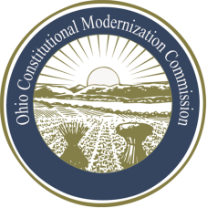 | Co-Chair  William G. Batchelder, Speaker  69th House District
Ohio Constitutional Modernization Commission

Finance, Taxation & Economic Development Roll Committee
Douglas Cole, Chair
Thursday, June 13, 2013

Douglas Cole, Chair | Karla Bell, Vice Chair
Chair Cole called the meeting of the Finance, Taxation, and Economic Development Committee to order at 9:38a.m. A quorum was not present, so the committee proceeded as a sub-committee.

The Chair recapitulated what occurred at the last meeting and introduced the presenters to the committee members. Greg Stype of Squire Sanders and Kurt Kauffman of the Office of Budget Management gave a joint presentation on the state debt including limitations on debt, debt authorizations, and sinking fund provisions. With the arrival of another member, the quorum was filled and they resumed activity as a full committee. Questions were asked throughout the presentation.

Chairman Cole asked member if they would like a similar presentation on taxation at the next meeting to which they agreed. The Committee also discussed dates in July for their next meeting.

With no further business, the committee adjourned at 11:05a.m.

